Add and manage users with Linux commands

Description

This project simulated the full lifecycle of a Linux user account, from onboarding to account removal, while managing group memberships and file ownerships along the way. The scenario involved creating a new employee account (researcher9), assigning them to the appropriate primary group, transferring ownership of a project file, adding them to a secondary department group, and removing both their account and associated private group when they left the organization. This exercise mirrors real-world Linux system administration practices for managing user and group access.

Tasks

Task 1: Add a new user and assign primary group
- Create the new user researcher9
- Assign research_team as their primary group
- Alternatively, you could create the user and assign the group in one command:
  - sudo useradd researcher9 -g research_team

Task 2: Assign file ownership
- Make researcher9 the owner of project_r.txt

Task 3: Add the user to a secondary group
- Add researcher9 to the sales_team group as a supplementary group (keep research_team as primary)

Task 4: Delete the user and clean up the group.
- Remove the researcher9 account from the system.
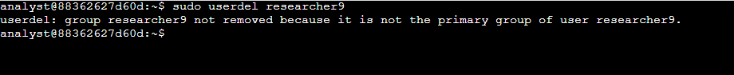
- Delete the unused researcher9 group that was automatically created during user creation.
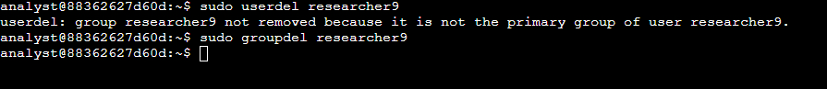

Tasks Completed
- Add a new user—Created a new user account for researcher9 using useradd and assigned them to the research_team primary group with usermod -g.
- Assign file ownership—Transferred ownership of /home/researcher2/projects/project_r.txt to researcher9 using the chown command, giving them direct responsibility for the file.
- Add to a secondary group—Used usermod -a -G to add researcher9 to the sales_team supplementary group while retaining research_team as the primary group.
- Delete the user and clean up—Removed the researcher9 account using userdel and deleted the unused researcher9 private group with groupdel to maintain a clean group structure.

Skills Demonstrated
- User account creation and deletion (useradd, userdel)
- Group management (usermod, groupdel)
- Assigning primary and supplementary group memberships
- File ownership transfer (chown)
- Best practices for Linux user lifecycle management

Glossary
sudo useradd researcher9
- sudo—Runs the command with administrator privileges.
- useradd—Creates a new user account.
- researcher9—The username for the new account.
sudo usermod -g research_team researcher9
- usermod—Modifies an existing user’s settings.
- -g research_team – Sets the user’s primary group to research_team.
- researcher9 – The account to modify.
Alternative: sudo useradd researcher9 -g research_team
- Combines user creation and primary group assignment in one step.
sudo chown researcher9 /home/researcher2/projects/project_r.txt
- chown—Changes the ownership of a file or directory.
- researcher9 – The new owner.
- /home/researcher2/projects/project_r.txt– The file to reassign.
sudo usermod -a -G sales_team researcher9
- -a – Appends to the user’s supplementary group list.
- -G sales_team – Adds sales_team as a supplementary group.
sudo userdel researcher9
- userdel—Deletes a user account.
- researcher9 – The account to delete.
sudo groupdel researcher9
- groupdel – Deletes a group.
- researcher9 – The group name to remove.

